DSA

ASSIGNMENT -1

1.

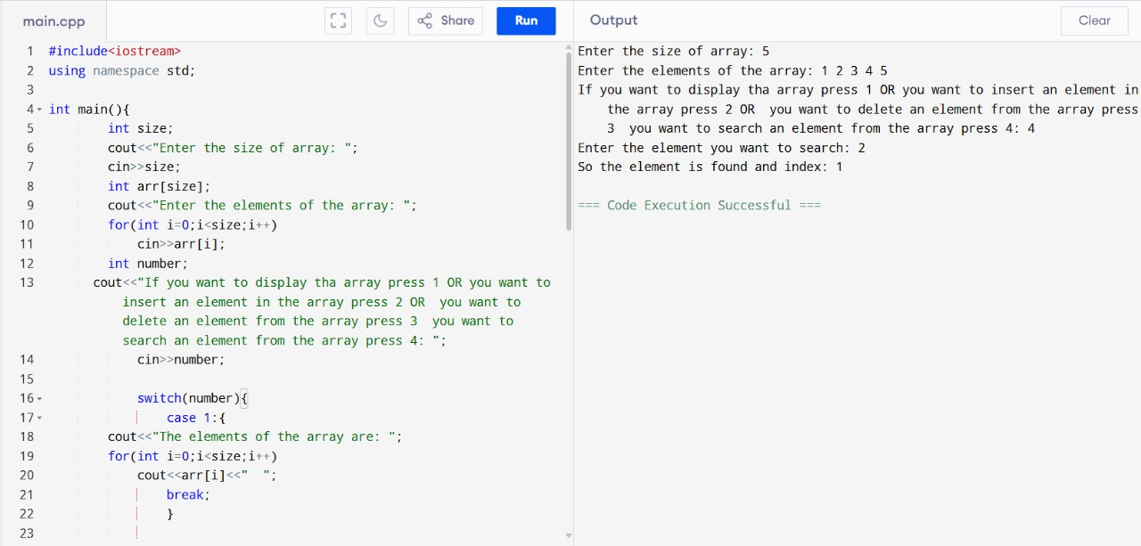

2.

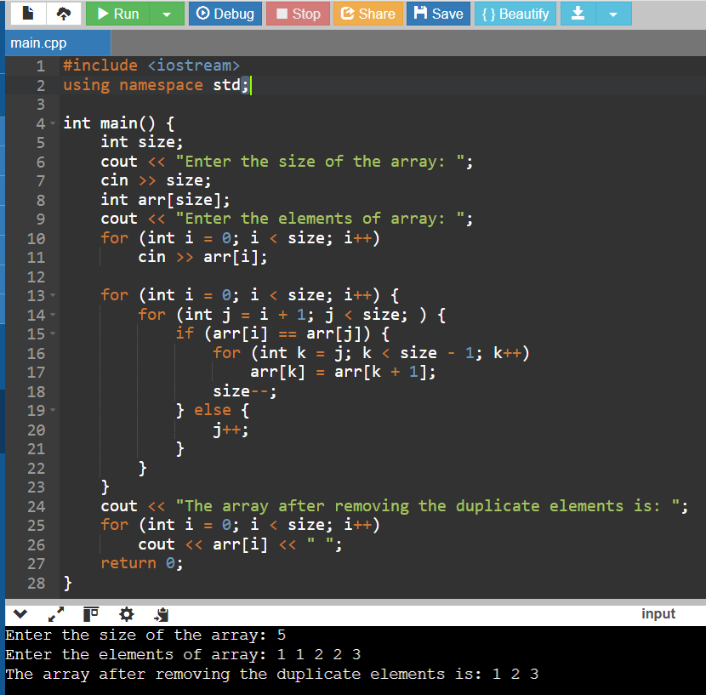

3.

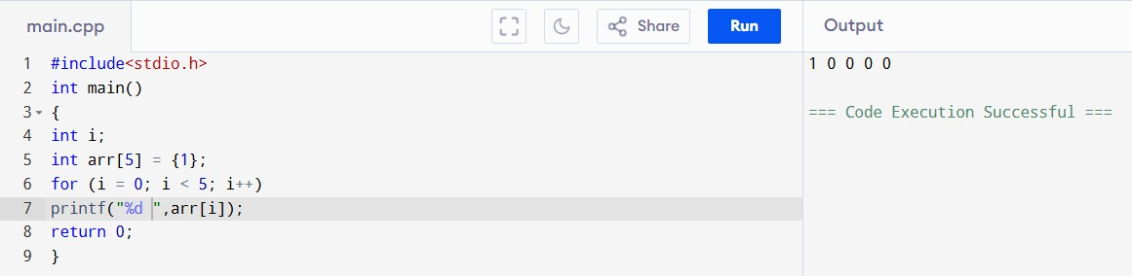

4(a).

4(b).

4(c).

5.

ASSIGNMENT-2

1.

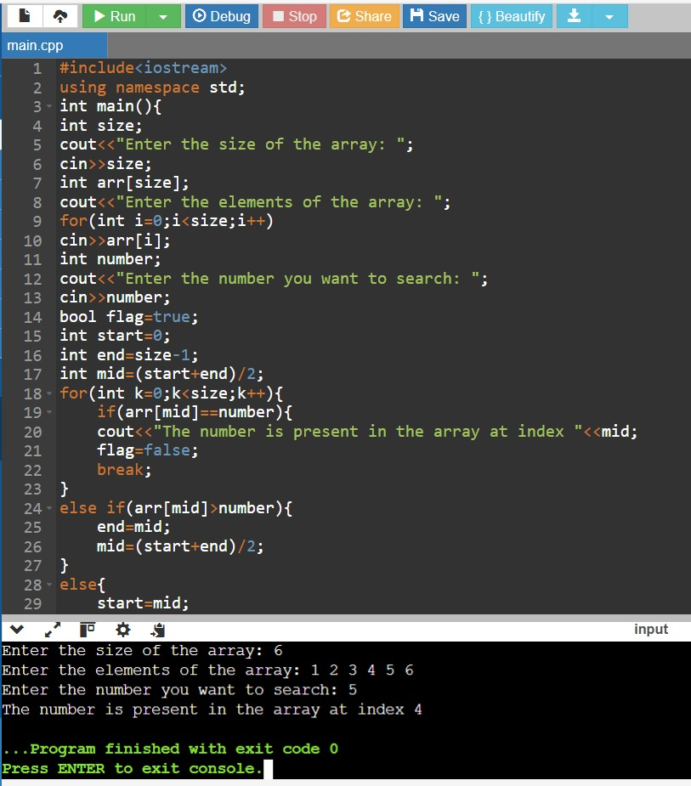

2.

3(a).

3(b).

4(a).

4(b).

4(c).

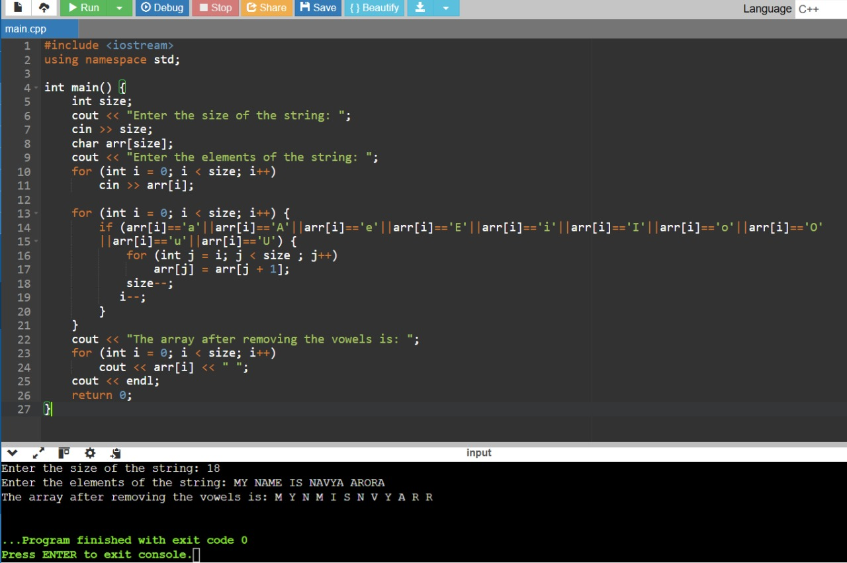

4(d).

4(e).

5(a).

5(b).

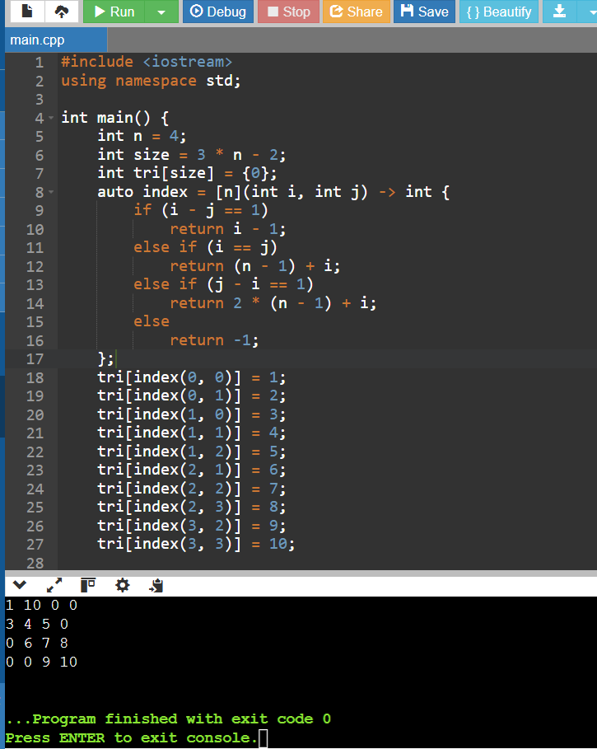

5(c).

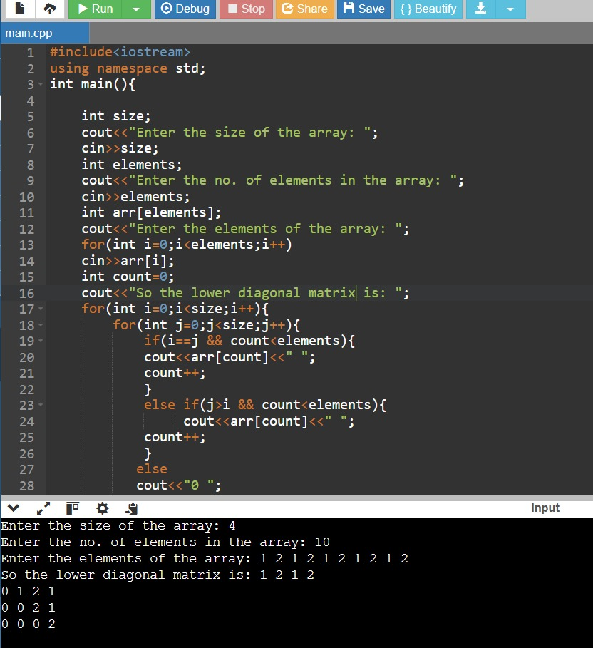

5(d).

5(e).

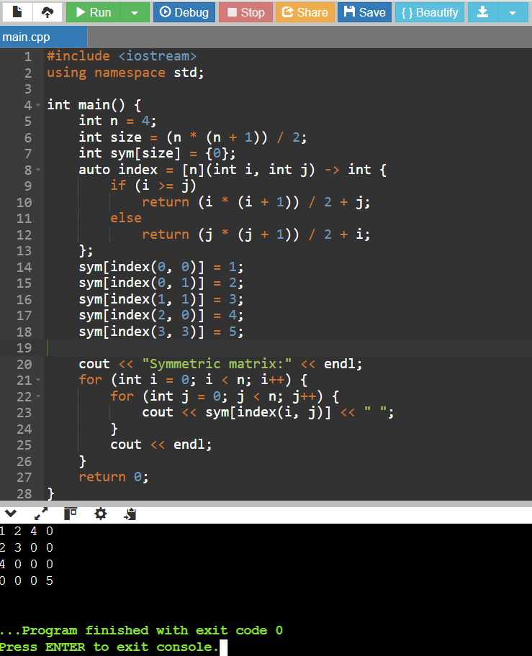

6(a).

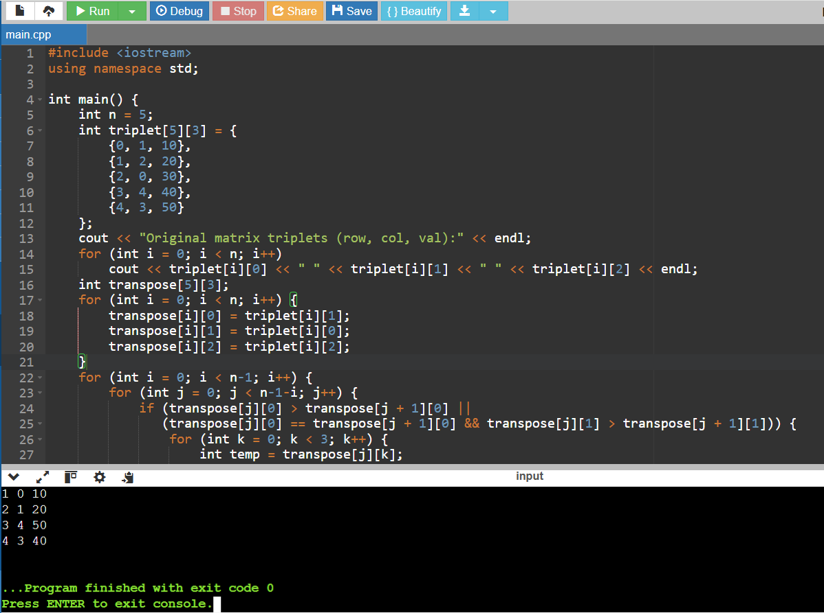

6(b)

6(c).

7.

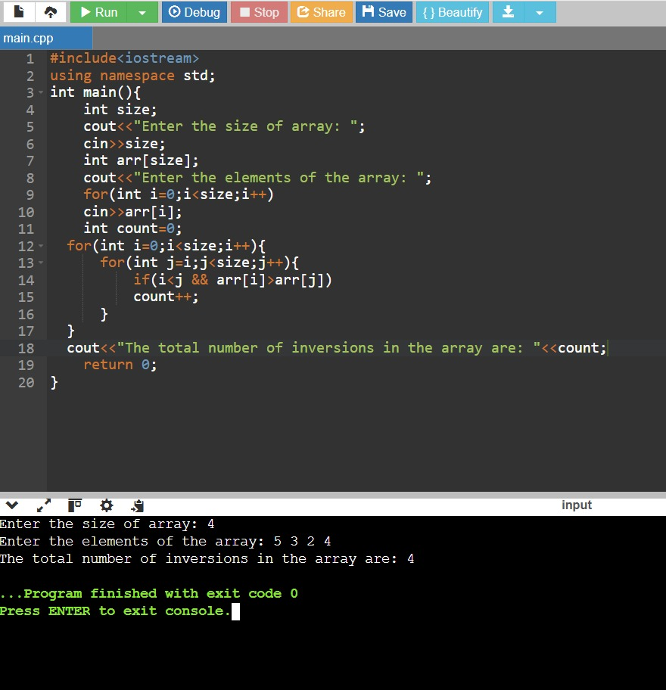

8.

